|  |  |
| --- | --- |
| Google Classroom | Version: <1.0> |
| Use-case-Realization Specification: Complete Assignment | Date: <05/Dec/21> |
| <document identifier> | |

Revision History

|  |  |  |  |
| --- | --- | --- | --- |
| **Date** | **Version** | **Description** | **Author** |
| <05/Dec/21> | <1.0> | <Initial version> | Bui Hoang Quan |
| <07/Dec/21> | <1.1> | <Edited version> | Bui Hoang Quan |
|  |  |  |  |
|  |  |  |  |

**Google Classroom**

**Online Learning Platform**

Version 1.1

# Introduction

## Purpose

This Use-case Realization Specification provides an overview of how the corresponding use-case is realized to the design model in terms of collaborating objects.

## Scope

This document only applies to the Use-case: Archive class

## Definitions, Acronyms, and Abbreviations

None

## References

## Overview

In part 2, the use-case realization will be further illustrated by using class diagrams and sequence diagrams. Later on, from the realized diagrams, other requirements that have not been considered in the design model will be listed in section 3 – Derived Requirements.

# Flow of Events—Design

## sequence diagram

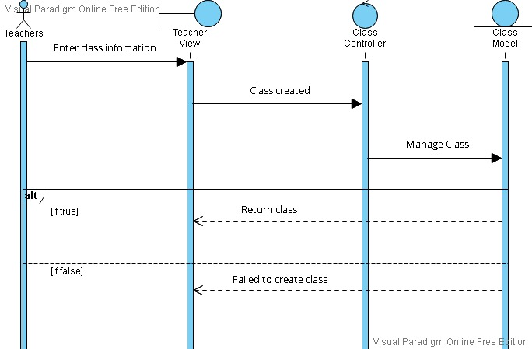

## class diagram

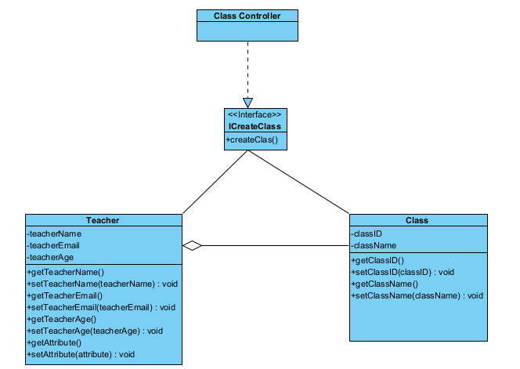

# Derived Requirements